PicturebookWebsite Screenshot

Jia Guo

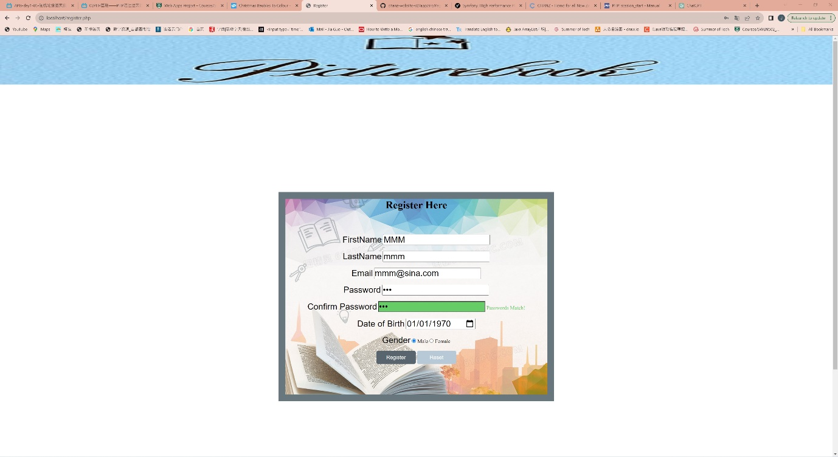register page(HTML, CSS, JavaScript, PHP, databases)

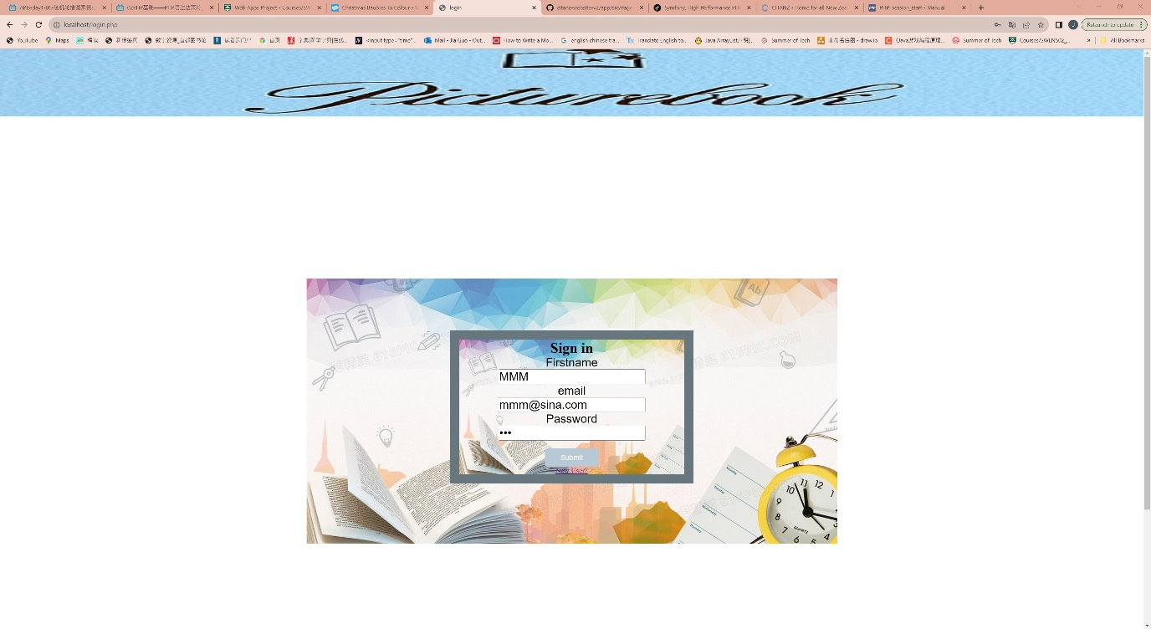login page(HTML, CSS, JavaScript, PHP, databases)

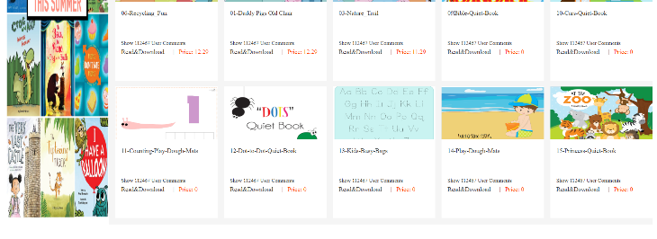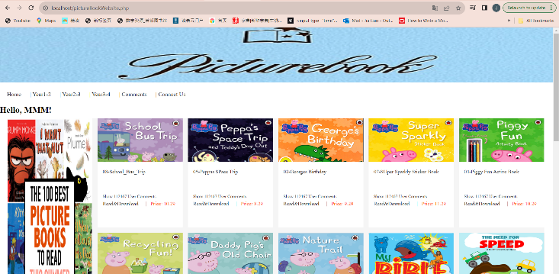

Picturebookwebsite page(HTML, CSS, JavaScript, PHP,

databases)

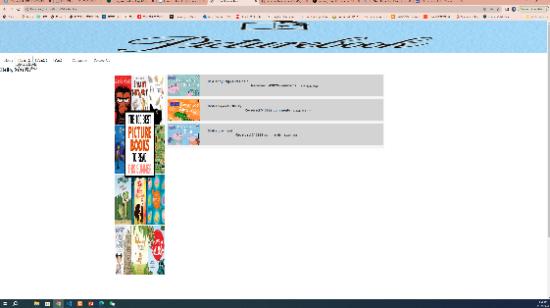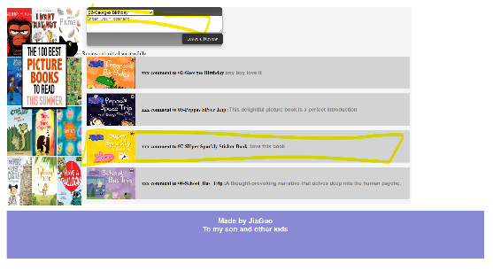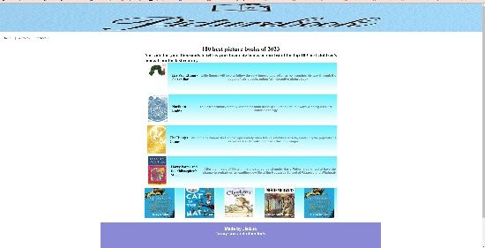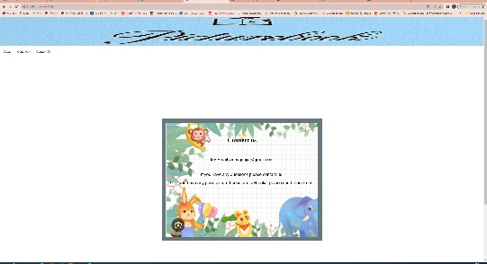

Select bar(HTML, CSS, JavaScript, PHP, databases) Comments page(HTML, CSS, JavaScript, PHP, databases) news page (HTML, CSS) connectus page (HTML, CSS)